**Project Scope**

Scope management is one of the most important processes for system development life cycle (SDLC). Through scope management, we can monitor and control risks with a primary focus on scope creep. The processes include defining scope, creating work breakdown structure, verify scope and control scope. During preliminary investigation, we try to define the scope from the perspectives of time, cost and resources. The resources of the project include project champion, project sponsor and team members. The cost of the project is dependent on the budget of sponsor and the time each member spend working on the project. The time of the project is strictly limited by the curriculum, with the deadline of project delivery and sponsor sign-off on April 23rd. 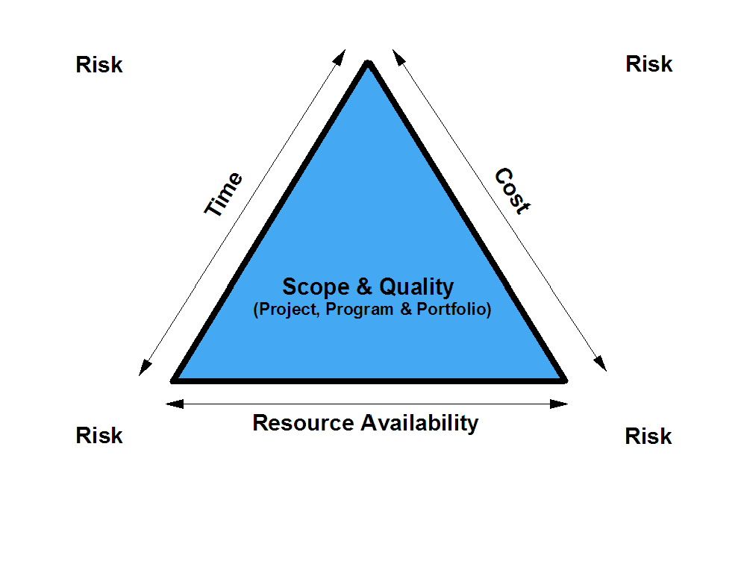

The Scope Statement from Project Charter is: This project aims to address the current lack of an inventory management system in the CUSD Extensions Department. The goal of this project is not to develop inventory handling or storage procedures, but to implement a web-based system capable of meeting the program’s general inventory tracking needs.

**Must do**

Create a web-based inventory system with functions of check-in, check-out, reserve, check reservations.

Have the option to discard of an asset.

Create functions to add and discard assets, add people and users, modify table columns, reporting tool and data backup.

**Should do**

Provide the platform with mobile compatibility.

Provide an admin email and account that can be transferred to a new worker should Liz leave.

Have the ability to upload pictures to the database.

Ability to transfer database into microsoft excel.

**Could do**

Generate barcodes or QR codes for each item.

Build our own server for the database.

Documentation for the application.

**Won’t do**

Data entry for database. She requested that volunteers do this for her.

Provide user training for the system.

Sorting system for the physical room.

**Identify Constraints**

Project end date to be limited by the end of semester. Specifically, work on project must not extend past April 23rd, 2019.

Lizeth will be leaving for two weeks during the month of February, as well as the first week of March, which limits the communication between project sponsor and team. Due to the bureaucratic nature of school districts, the project budget is negligible, limited only to reasonably small, one-time purchases (to be authorized and then funded by the project sponsor)

**Estimate Project Development Time**

With the work breakdown structure completed during class meeting, we had originally estimated that the project would take 116 hours to complete.

**Initial WBS (2/15/19)**

This was our original work breakdown structure when we planned to create the application from scratch. We made changes to this along the way as we found alternative solutions to the project. 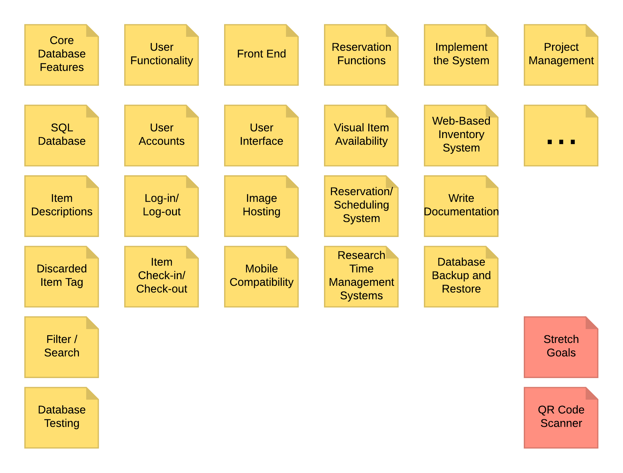

**Final WBS (2/18/19)**

The following chart was our work breakdown structure after deciding to work with Snipe IT and WordPress plugins.

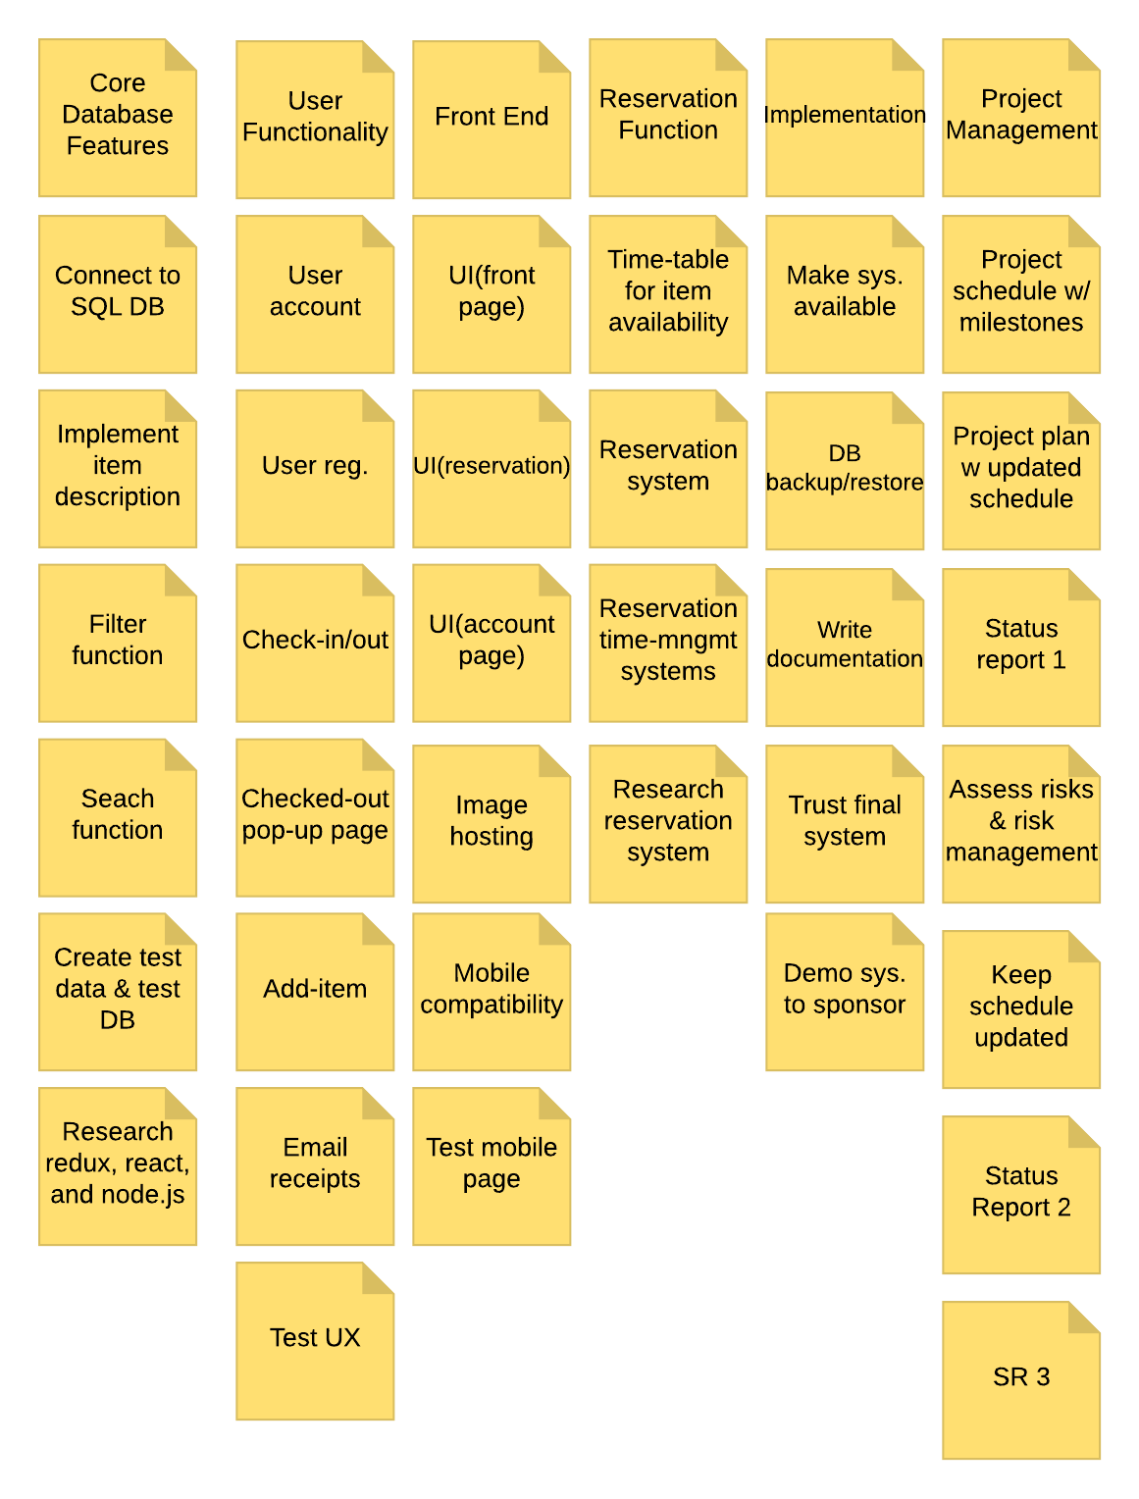

**Overall Task List**

|  |
| --- |
| Task List |
| **Inventory Management System for CUSD Extension Dept. Theater Program** |
| **Initiate** |
|  |
| Write Team Charter |
| **Plan** |
| Define Project Requirements |
| Develop project Charter |
| Create & Revise Work Breakdown Structure |
| Create Project Schedule |
|  |
| **Execute and Control** |
| Implement item descriptions |
| Create test data |
| Test system |
| Implement user accounts/registration |
| Implement check-in/checkout function/ column |
| Implement add item feature |
| Develop mobile compatibility |
| Test mobile compatibility |
| Research time management system |
| Create reservation system |
| Create time management system |
| Run system on Amazon Web Services |
| Demo system to sponsor |
| Final Test System |
| **Control** |
| Project Status Report 1 |
| Project Status Report 2 |
| Project Status Report 3 |
| **Close** |
| Finalize project presentation |
| Finalize project binders |
| Finalize SDLC binder |
| **Evaluate Project** |
| Peer Evaluation |
| Submit lesson learned |